mastering the Encoder-Decoder (Seq2Seq) architecture and preparing to understand Transformers and LLMs:

### **🔍 Core Understanding: Encoder-Decoder Architecture**

#### **✅ What it Solves**

* Input & output are both **variable-length sequences**
* Examples: **Machine Translation**, **Chatbots**, **Summarization**, **Speech Recognition**

#### **🧠 Architecture Components**

1. **Encoder**: Compresses input sequence into a **Context Vector**
   * Typically an LSTM or GRU
   * Final hidden & cell states = **summary of the input**
2. **Context Vector**: A fixed-size representation passed to the Decoder
3. **Decoder**: Expands the context into an output sequence  
   * Also uses LSTM
   * Starts with a **Start token**, continues generating till **End token**
   * Uses **Softmax** to output token probabilities at each step

#### **🔁 Training**

* Uses **Teacher Forcing**: Feeds ground truth word from previous step instead of predicted one
* Loss: **Categorical Cross-Entropy** for each time step
* Backpropagation through time (BPTT) is used

### **🛠️ Key Enhancements**

| **Technique** | **Purpose** | **Benefit** |
| --- | --- | --- |
| **Word Embeddings** | Replace one-hot vectors | Dense, low-dim, semantically meaningful |
| **Multi-layer LSTMs** | Stack multiple LSTMs | Better long-term memory, hierarchical learning |
| **Reverse Input Sequence** | Reverse encoder input | Improves gradient flow; helps alignment |
| **Large Vocabulary Tricks** | Use UNK, beam search | Reduce model confusion, improve fluency |

### **🧪 Practical Tips**

* Use a **Start-of-Sentence (SOS)** and **End-of-Sentence (EOS)** token
* During **inference**, do NOT use teacher forcing
* Use **beam search** for better output than greedy decoding
* Apply **attention mechanism** for long sequences (leads to Transformer idea)

### **📈 From Here to Transformers**

Once you're confident with this:

* Study **Attention** (Bahdanau and Luong-style)
* Move to **Transformers** (Vaswani et al., 2017): no RNNs, pure attention
* Then explore **pretrained LLMs** (BERT, GPT)

### **📚 Recommended Resources**

* 📄 Paper: [Sequence to Sequence Learning with Neural Networks](https://arxiv.org/pdf/1409.3215.pdf)
* 🎥 Video Explanation: [YouTube – Seq2Seq Explained](https://www.youtube.com/results?search_query=seq2seq+encoder+decoder)
* 🧑‍💻 Kaggle Dataset: [English-Hindi Dataset](https://www.kaggle.com/datasets/preetviradiya/english-hindi-dataset)
* 📘 Next: [Neural Machine Translation by Jointly Learning to Align and Translate](https://arxiv.org/pdf/1409.0473.pdf)

The **Encoder-Decoder architecture** using RNNs, LSTMs, or GRUs for sequence-to-sequence tasks has been foundational in deep learning, but it comes with several **limitations**. Below are the key limitations and how modern architectures have overcome them:

### **🚫 Limitations of the Encoder-Decoder Architecture**

#### **1. Fixed-Size Context Vector (Information Bottleneck)**

* **Problem**: The entire input sequence is compressed into a single vector (context vector) of fixed length, regardless of the input length.
* **Impact**: For long input sequences, this fixed-size vector fails to capture all the necessary details, leading to poor performance, especially in long or complex sentences.
* **Example**: Translating a long paragraph accurately becomes difficult because too much information is squeezed into one vector.

#### **2. Difficulty with Long-Term Dependencies**

* **Problem**: Even LSTM and GRU models, while better than vanilla RNNs, struggle with remembering dependencies that are far apart in the input.
* **Impact**: Words at the beginning of a sentence may get "forgotten" by the time the context vector is produced.

#### **3. Sequential Decoding**

* **Problem**: The decoder generates one token at a time using the previous output, making it inherently sequential.
* **Impact**: It cannot fully exploit GPU parallelization during inference, which slows down translation or other sequence generation tasks.

#### **4. Lack of Interpretability**

* **Problem**: There's no mechanism to understand which parts of the input contributed most to a particular output.
* **Impact**: Makes the model a black box and harder to debug or explain, especially in sensitive applications.

#### **5. Handling Variable-Length Inputs and Outputs**

* **Problem**: Although LSTMs can technically handle variable lengths, aligning input-output pairs becomes difficult for complex tasks like summarization or question answering.

### **✅ How These Are Overcome**

Modern approaches build on the Encoder-Decoder idea but solve these problems using advanced mechanisms.

#### **🧠 1. Attention Mechanism**

* **How it helps**:  
  + Instead of relying solely on a fixed-size context vector, **attention** allows the decoder to look at different parts of the input sequence for each output token.
* **Benefit**:  
  + Dynamically computes context based on relevance at each step → improves performance for long sequences.
* **Introduced in**: [Bahdanau et al., 2014](https://arxiv.org/abs/1409.0473)

#### **⚡ 2. Transformers**

* **How it helps**:  
  + Replaces recurrence (LSTMs) with self-attention, allowing models to process the entire sequence simultaneously.
* **Benefits**:  
  + No information bottleneck.
  + Much faster to train and more parallelizable.
  + Better at modeling long-range dependencies.
* **Introduced in**: [Attention Is All You Need (Vaswani et al., 2017)](https://arxiv.org/abs/1706.03762)
* **Use Cases**: Used in BERT, GPT, T5, BART, and other state-of-the-art models.

#### **🔁 3. Bidirectional Encoders**

* **How it helps**:  
  + Processes the input sequence in both forward and backward directions to get richer context.
* **Used in**: BERT and other Transformer-based models.

#### **🧠 4. Pre-trained Language Models**

* **How it helps**:  
  + Leverages vast amounts of unlabelled text data for pretraining, then fine-tunes for specific tasks.
* **Examples**:  
  + BERT (for encoding tasks), GPT (for generation), T5/BART (for Seq2Seq tasks)

### **✅ Summary Table**

| **Limitation** | **Solution** | **Key Model** |
| --- | --- | --- |
| Fixed-size context vector | Attention mechanism | Bahdanau Attention |
| Long-term dependencies | Transformers & self-attention | Transformer |
| Sequential decoding | Transformers (non-recurrent architecture) | Transformer |
| Lack of interpretability | Attention weights | Attention models |
| Poor scalability on long input | Transformer’s parallel processing | GPT, BERT, T5 |

# **Encoder Decoder | Sequence-to-Sequence Architecture | Deep Learning**

🔗 Research Paper:<https://arxiv.org/pdf/1409.3215.pdf>

<https://medium.com/analytics-vidhya/encoder-decoder-seq2seq-models-clearly-explained-c34186fbf49b>

Here are notes on the Encoder-Decoder architecture for Sequence-to-Sequence data, based on the provided sources:

The Encoder-Decoder architecture is a foundational concept in deep learning for solving **Sequence-to-Sequence (Seq2Seq)** problems. Understanding this architecture is presented as a starting point for the journey towards understanding more advanced models like Transformers and Large Language Models (LLMs). Although these architectures may not be used as widely today, they provide an important basic foundation.

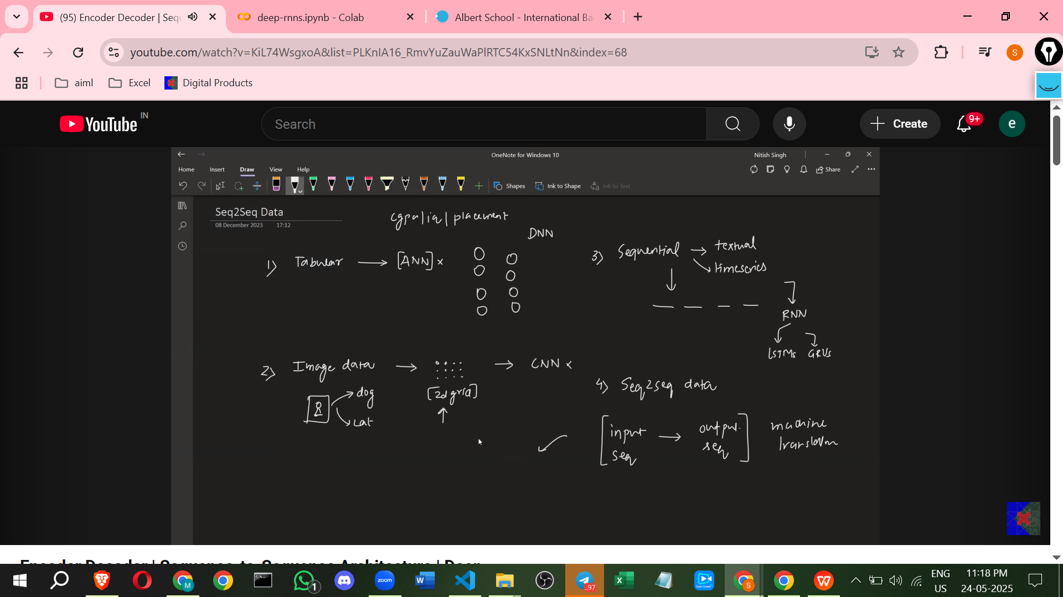

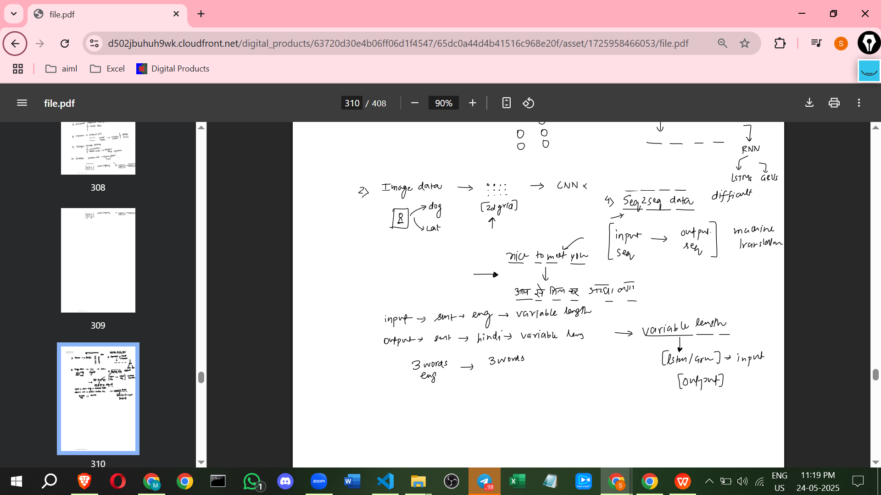

**What is Sequence-to-Sequence Data?**

* Seq2Seq data involves both **input and output being sequences**.
* A primary example is **Machine Translation**, where an input sentence in one language (e.g., English: "Nice to meet you") is converted into an output sentence in another language (e.g., Hindi: "आप से मिलकर अच्छा लगा"). This is the running example used to explain the architecture.

**Why is Handling Seq2Seq Data Difficult?**

Solving Seq2Seq problems is considered challenging due to three main factors:

1. **Variable Length Input:** The input sequence (e.g., an English sentence) can have a variable length, ranging from a few words to hundreds.
2. **Variable Length Output:** The output sequence (e.g., a Hindi sentence) also has a variable length.
3. **Non-Matching Lengths:** There is no guarantee that the output sequence will have the same number of items as the input sequence. An English sentence of four words might translate to a Hindi sentence of six words, for instance.

* Dealing with variable lengths in both input and output, and the mapping between them, is highlighted as the biggest challenge.
* While handling variable length input was partially learned with models like LSTMs and GRUs, handling variable length *output* is a challenge specifically addressed by the Encoder-Decoder architecture.

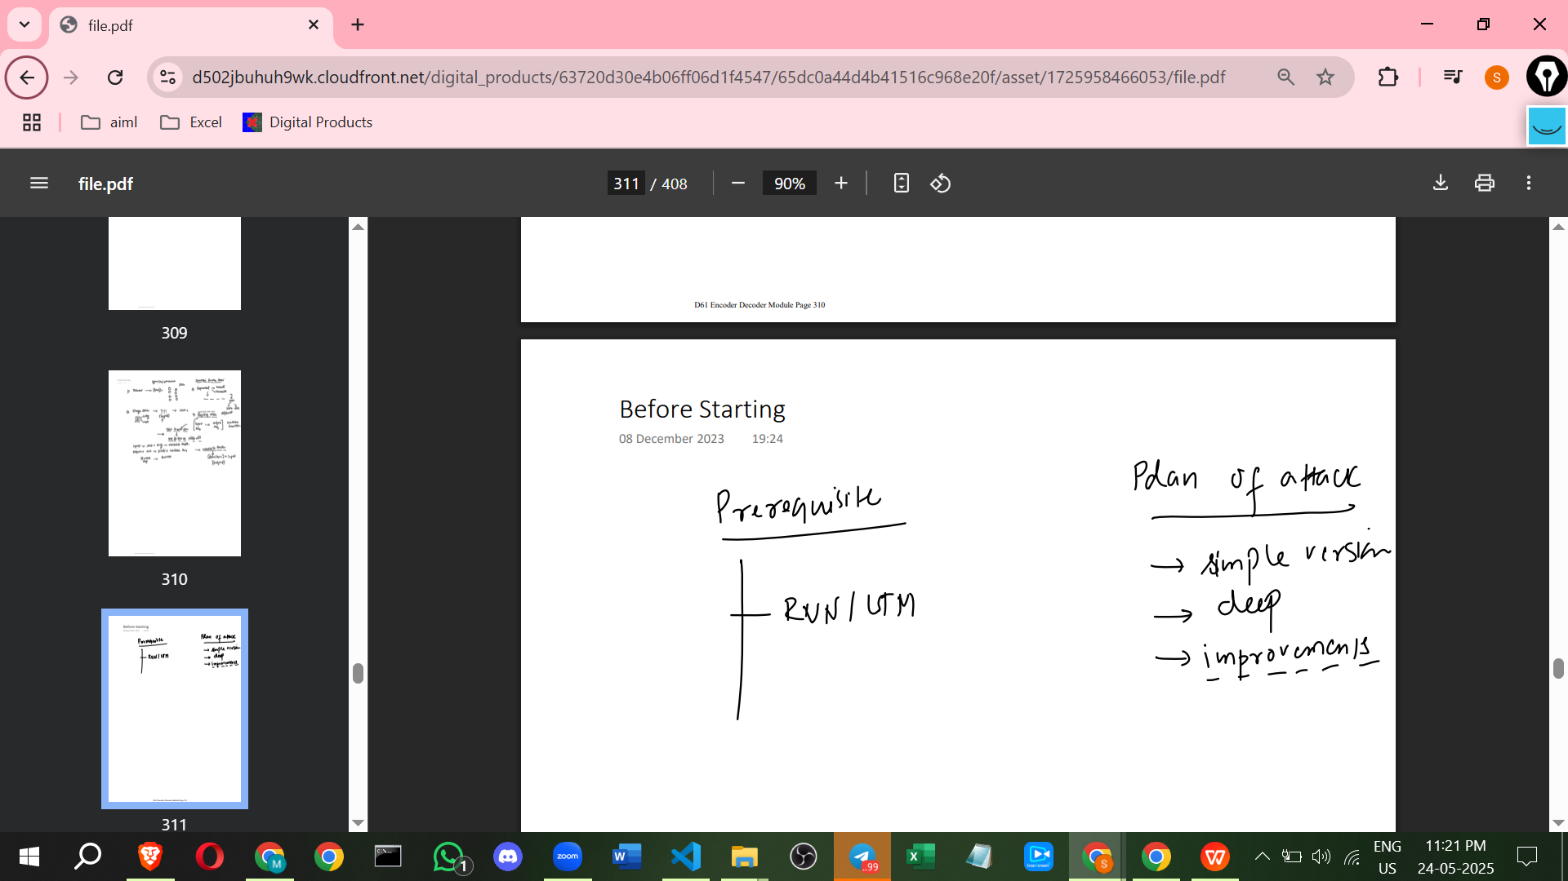

**Encoder-Decoder Architecture High-Level Overview**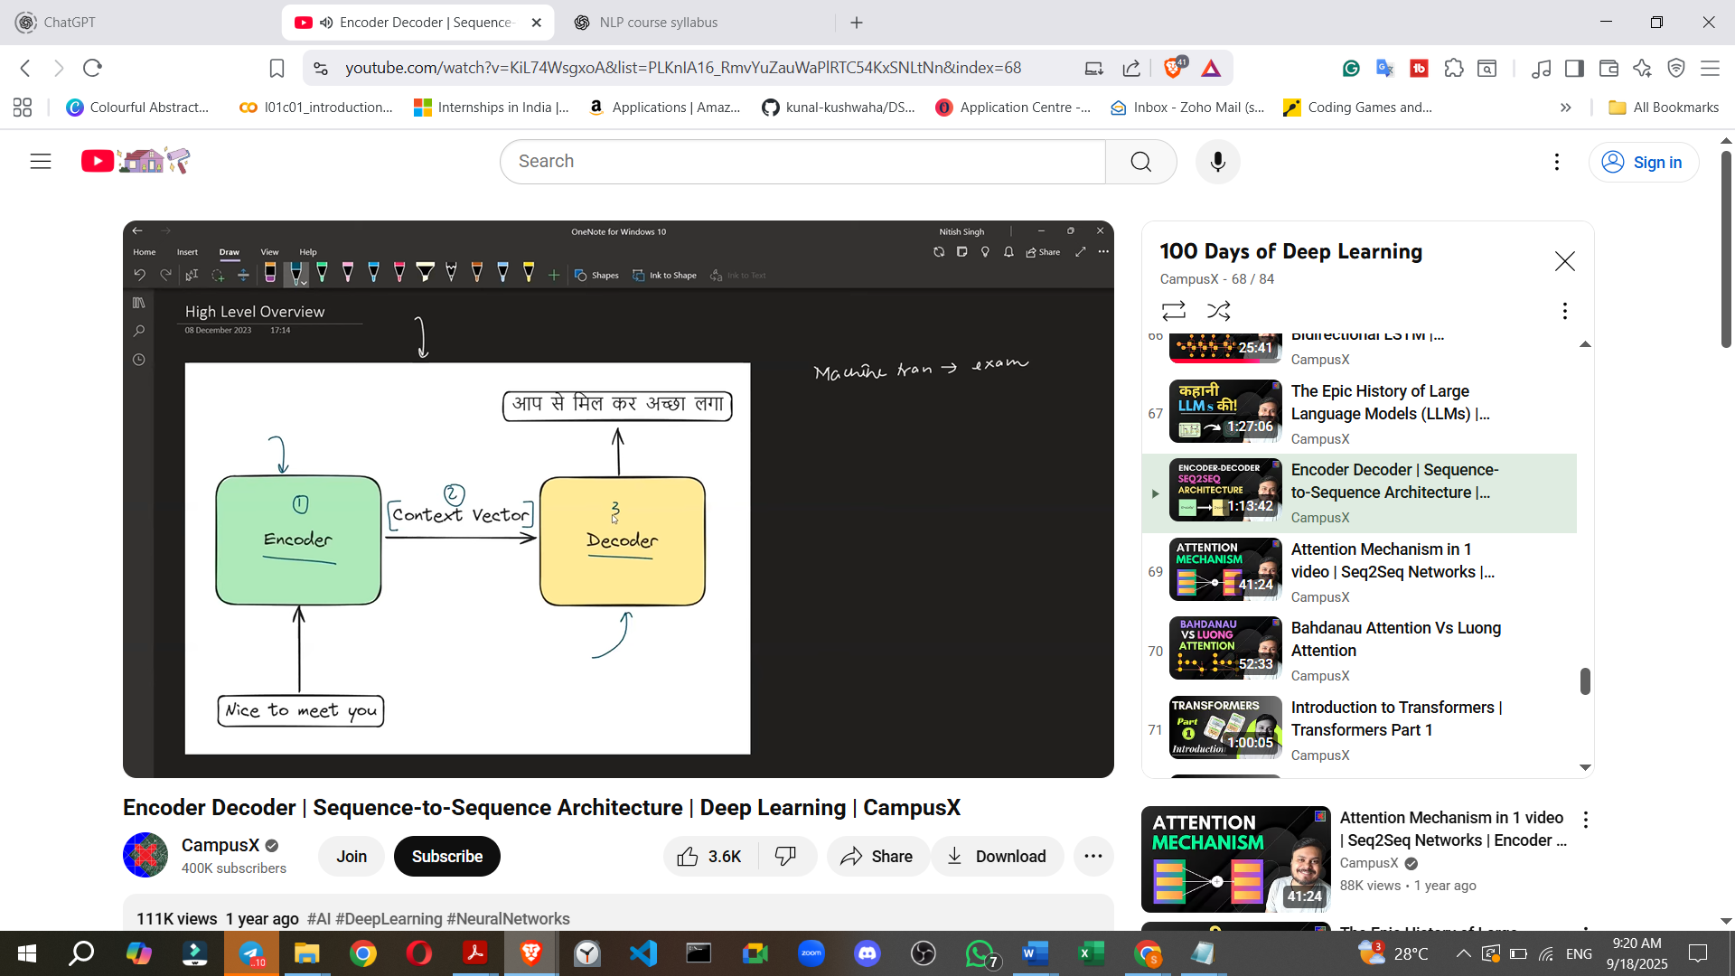

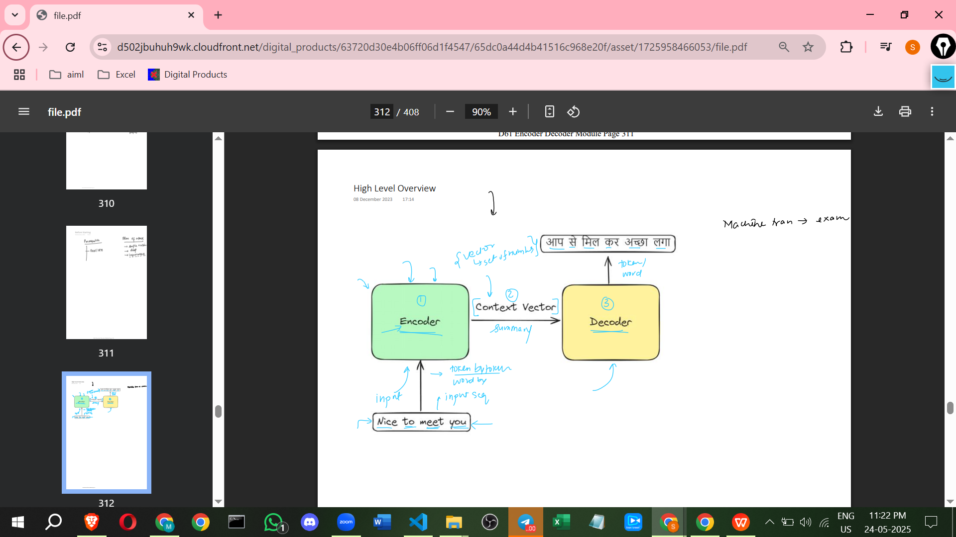

* The architecture, as the name suggests, is composed of two main blocks: an **Encoder** and a **Decoder**.
* These two blocks are connected by something called a **Context Vector**.
* The **Encoder**'s purpose is to process the input sequence.
* The **Decoder**'s purpose is to produce the output sequence.

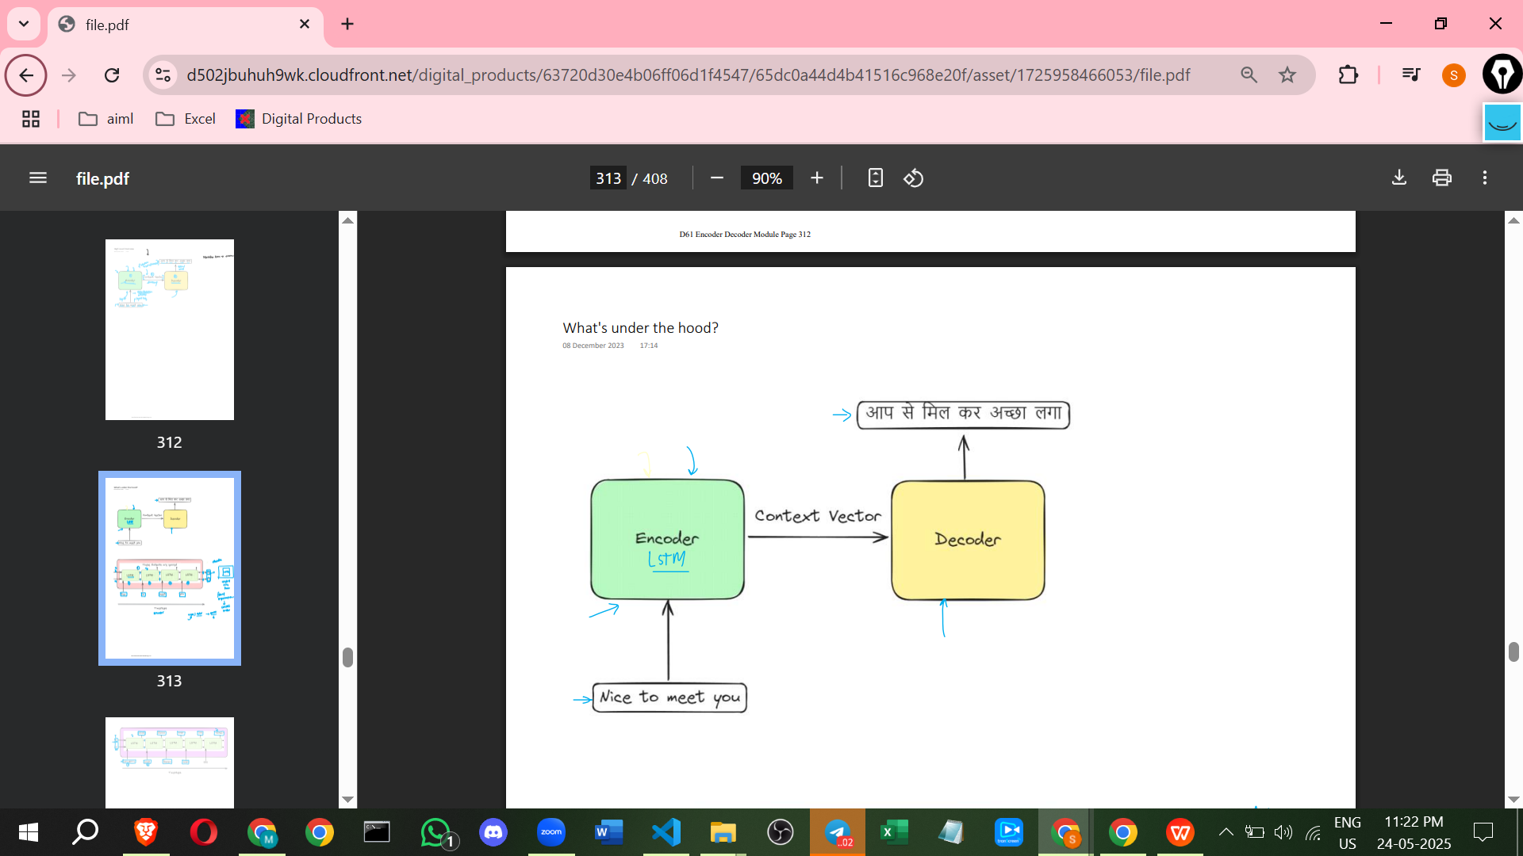

**Components Explained**

1. **Encoder:**

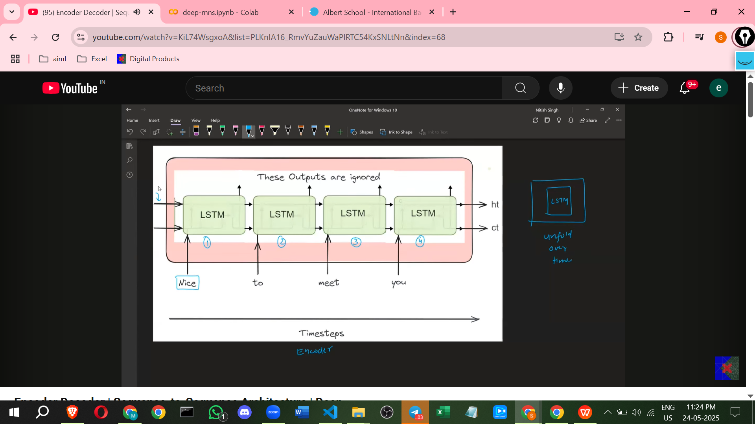

* + Takes the input sequence (e.g., an English sentence) **token by token** (which can be thought of as word by word).
  + Its job is to **understand, capture the essence, and summarise** the entire input sequence.
  + The Encoder outputs a vector (a set of numbers) which is the **Context Vector**. This vector is the summary of the input sentence based on the Encoder's processing.
  + Internally, the Encoder is typically implemented using an **LSTM (Long Short-Term Memory)** network. This LSTM cell is 'unfolded' over time steps to process the sequence.
  + The **final hidden state (Ht) and cell state (Ct)** of the Encoder's LSTM, after processing the entire input sequence, become the **Context Vector**.
  + While LSTM is commonly used (and was used in the original paper), **GRUs (Gated Recurrent Units)** can also be used. Standard RNNs are generally avoided due to issues like the vanishing gradient problem.

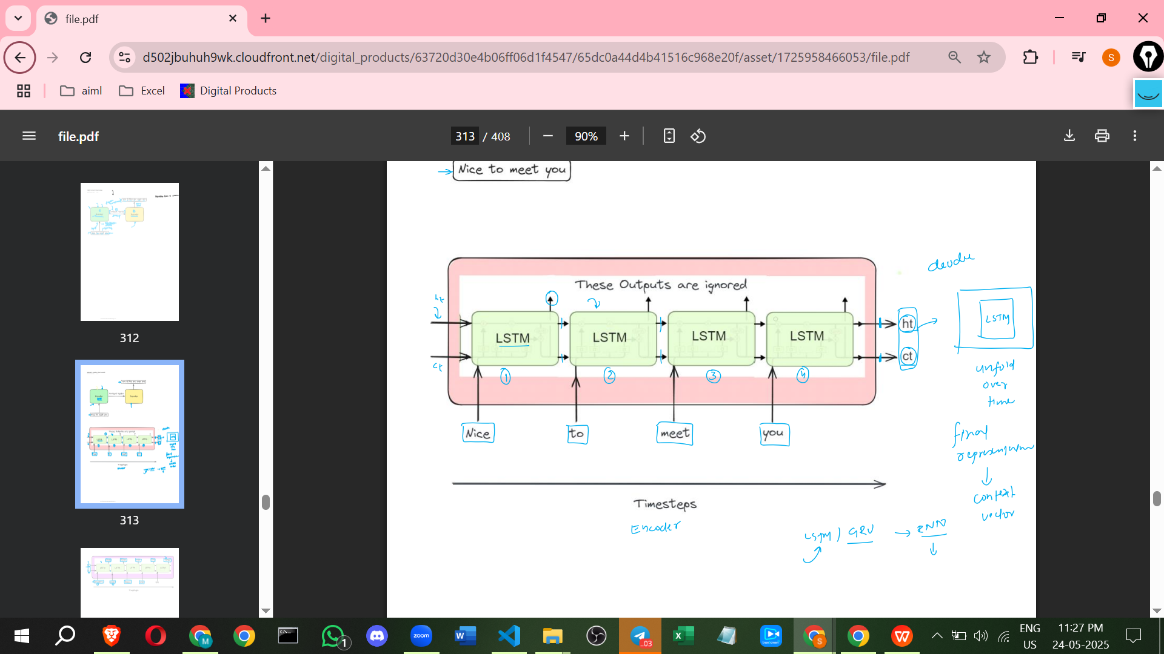

1. **Decoder:  
   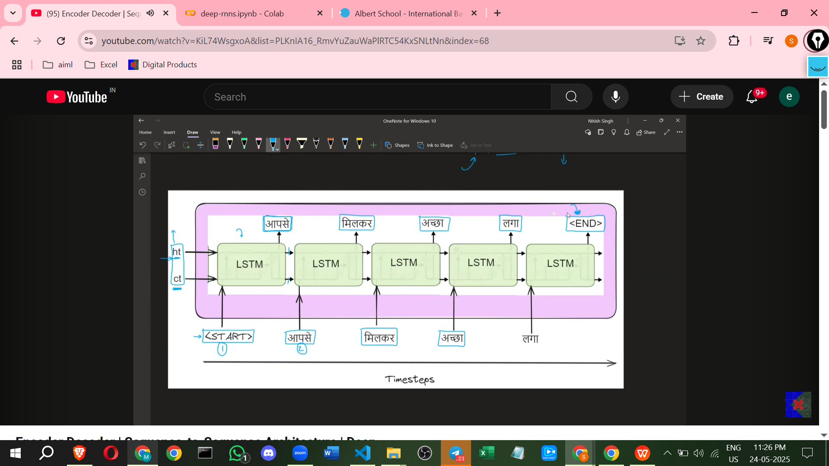** 
   * Receives the **Context Vector** from the Encoder.
   * Its task is to **understand** the Context Vector and then **print output token by token** (word by word).
   * The Decoder is also typically an **LSTM**, but it is a *separate* LSTM network from the Encoder.
   * A crucial link is established by setting the Decoder's **initial hidden state and cell state** to be exactly equal to the Encoder's **final hidden state and cell state** (the Context Vector). This provides the Decoder with the summary/context of the input sequence.
   * To begin producing output, the Decoder is initially given a special **Start** symbol as input, alongside the Context Vector.
   * At each subsequent time step, the Decoder takes its **internal state** (updated hidden and cell states), the **Context Vector**, and the **output word from the *previous* time step** as input to produce the next word.
   * The Decoder generates its output for a step by passing its internal representation through a **Softmax Layer**.
   * The Softmax layer has a number of nodes equal to the size of the **output vocabulary** (including Start and End symbols). It outputs a probability distribution over all possible output words.
   * The word with the **highest probability** according to the Softmax output is selected as the predicted output word for that time step.
   * The decoding process continues until the Decoder outputs a special **End** symbol.
2. **Context Vector:**
   * As mentioned, this is a **vector (set of numbers)**.
   * It serves as the **summary or representation of the entire input sequence** as generated by the Encoder.
   * It is the **communication bridge** between the Encoder and the Decoder.

**Training Process**

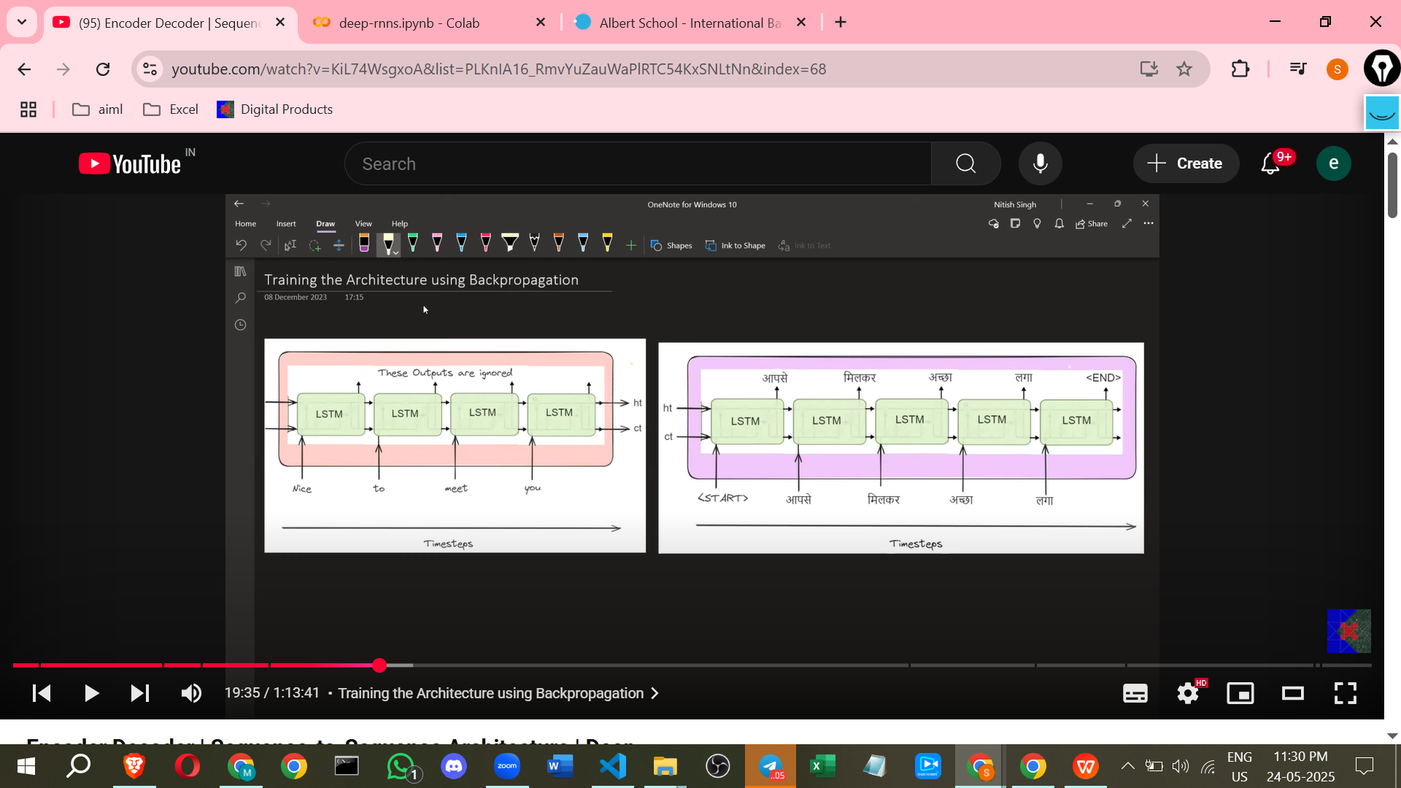

Training requires a **Parallel Dataset**, containing pairs of input sequences and their corresponding correct output sequences (e.g., English sentences and their Hindi translations). This is a form of supervised learning.  
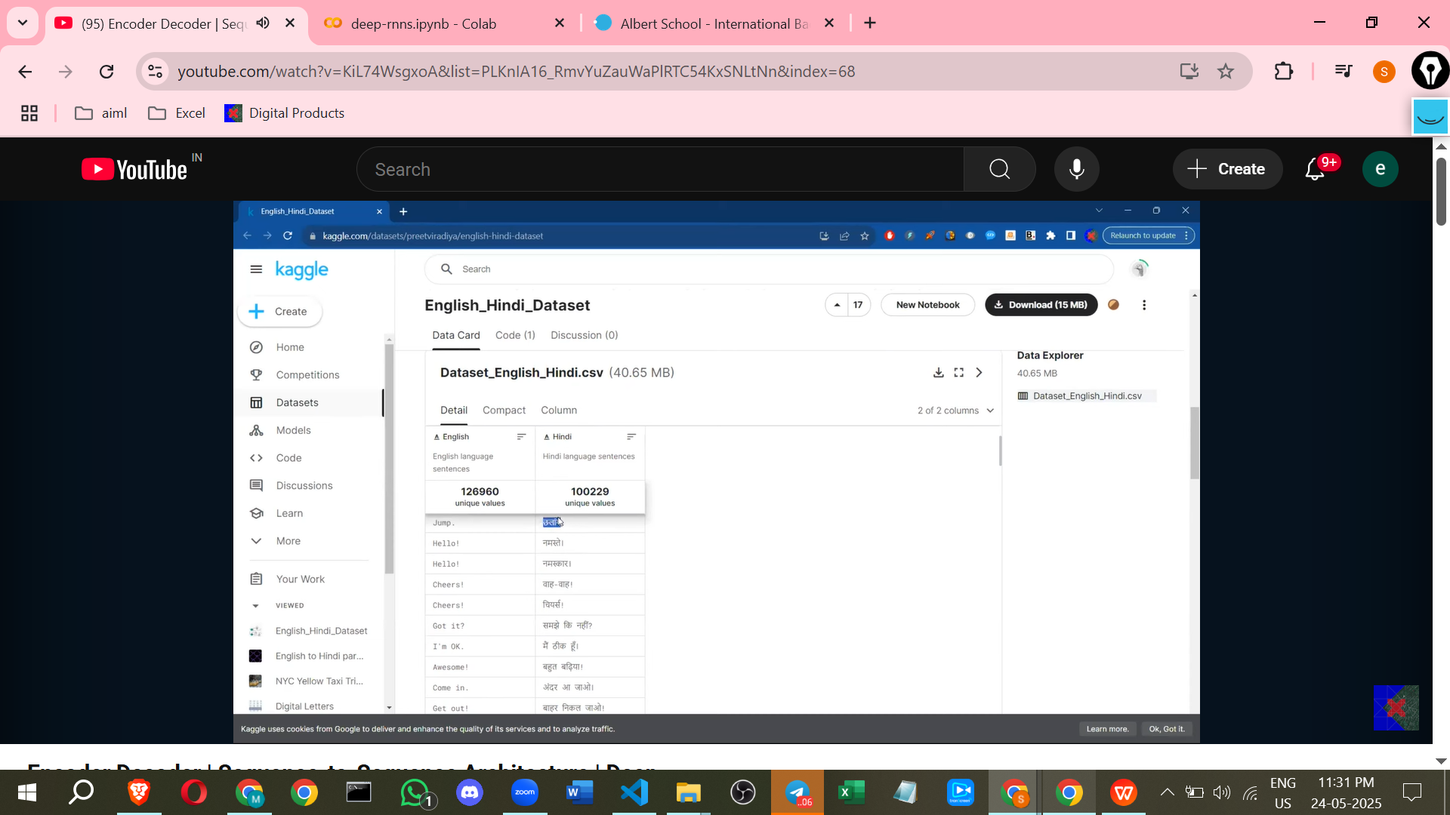

<https://www.kaggle.com/datasets/preetviradiya/english-hindi-dataset>

**Data Preparation:**

* + Sentences are **tokenized** into words.
  + Words are converted into numerical representations, typically using **One-Hot Encoding**. A vocabulary is created for both input and output languages. The output vocabulary must include special **Start** and **End** symbols. Each token is represented by a vector with a '1' at the index corresponding to the token in the vocabulary and '0' elsewhere.

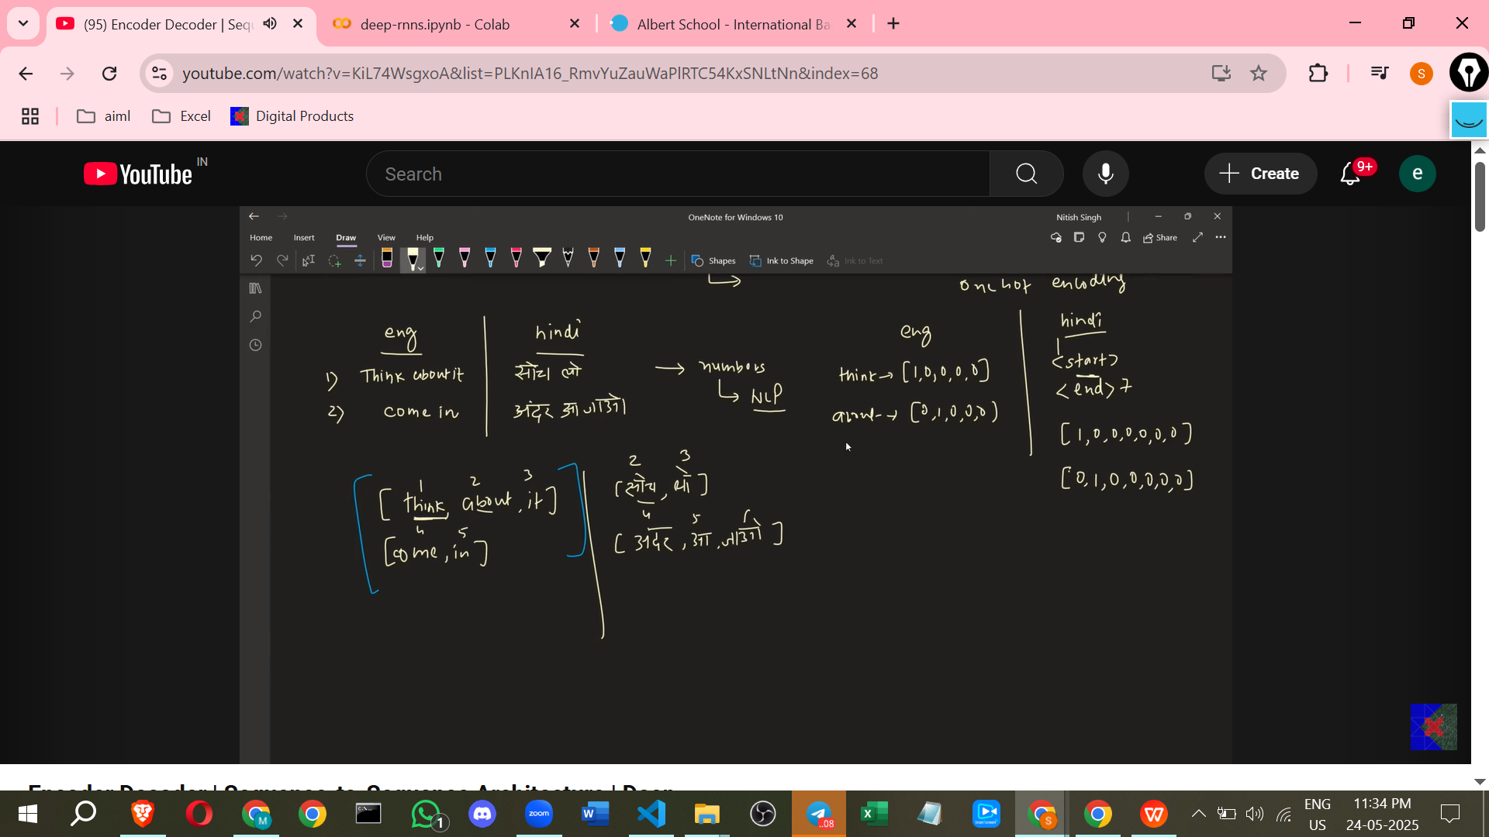

Training

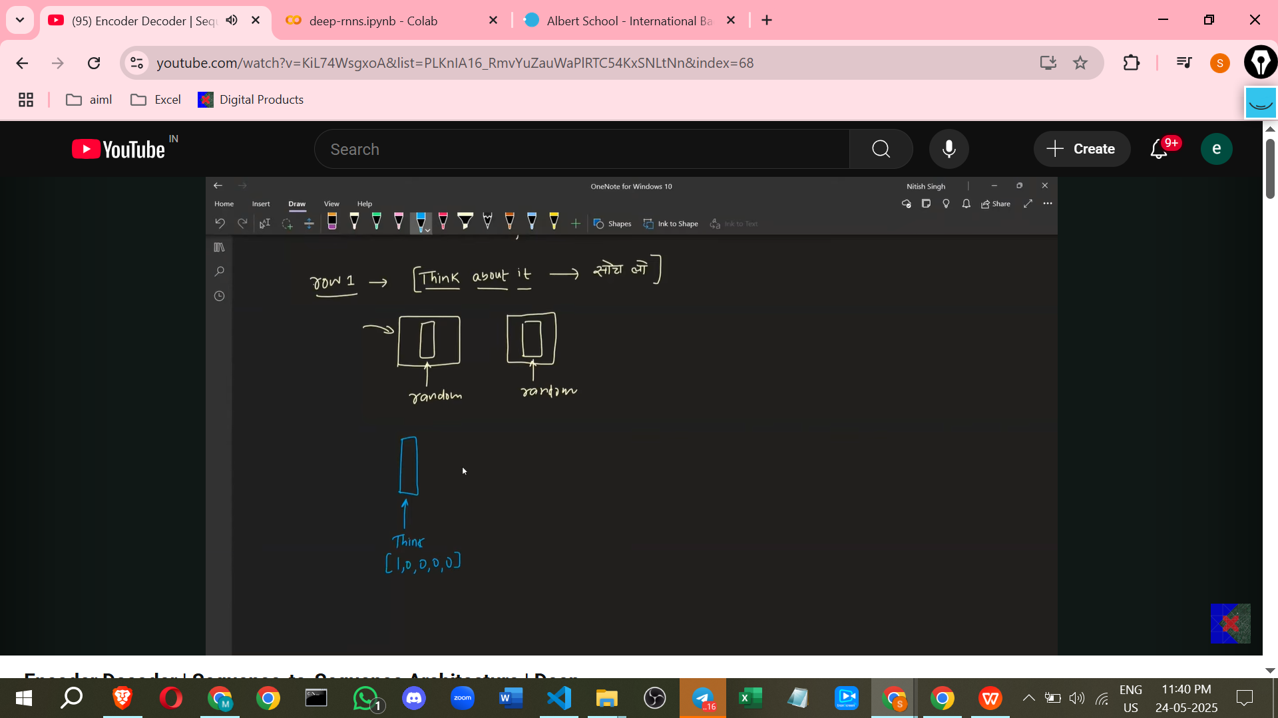

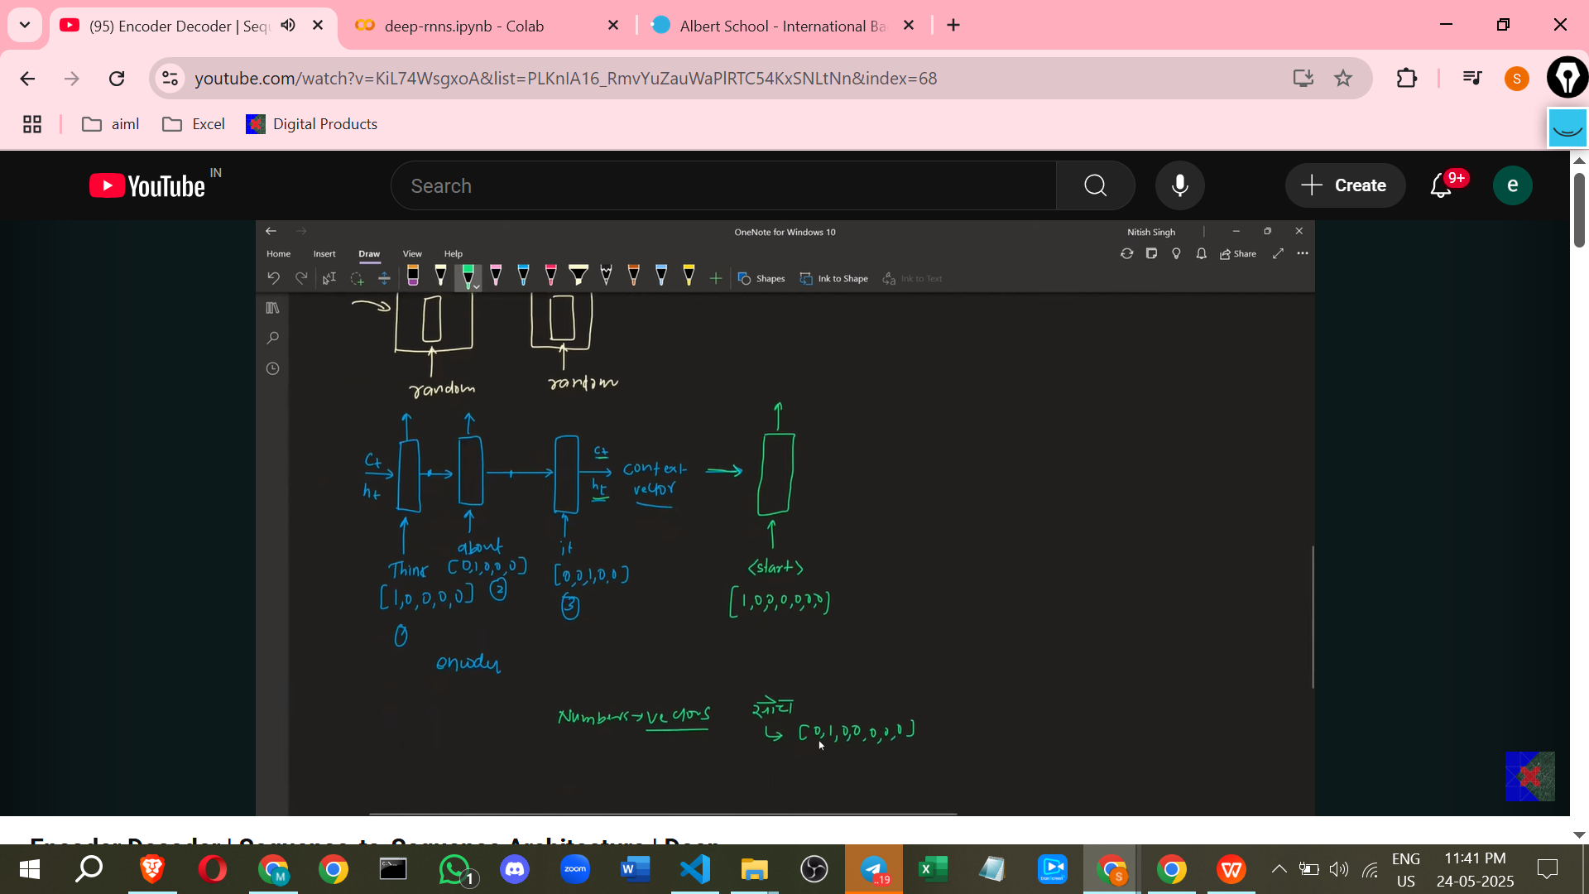

Y_predict ,actual predict

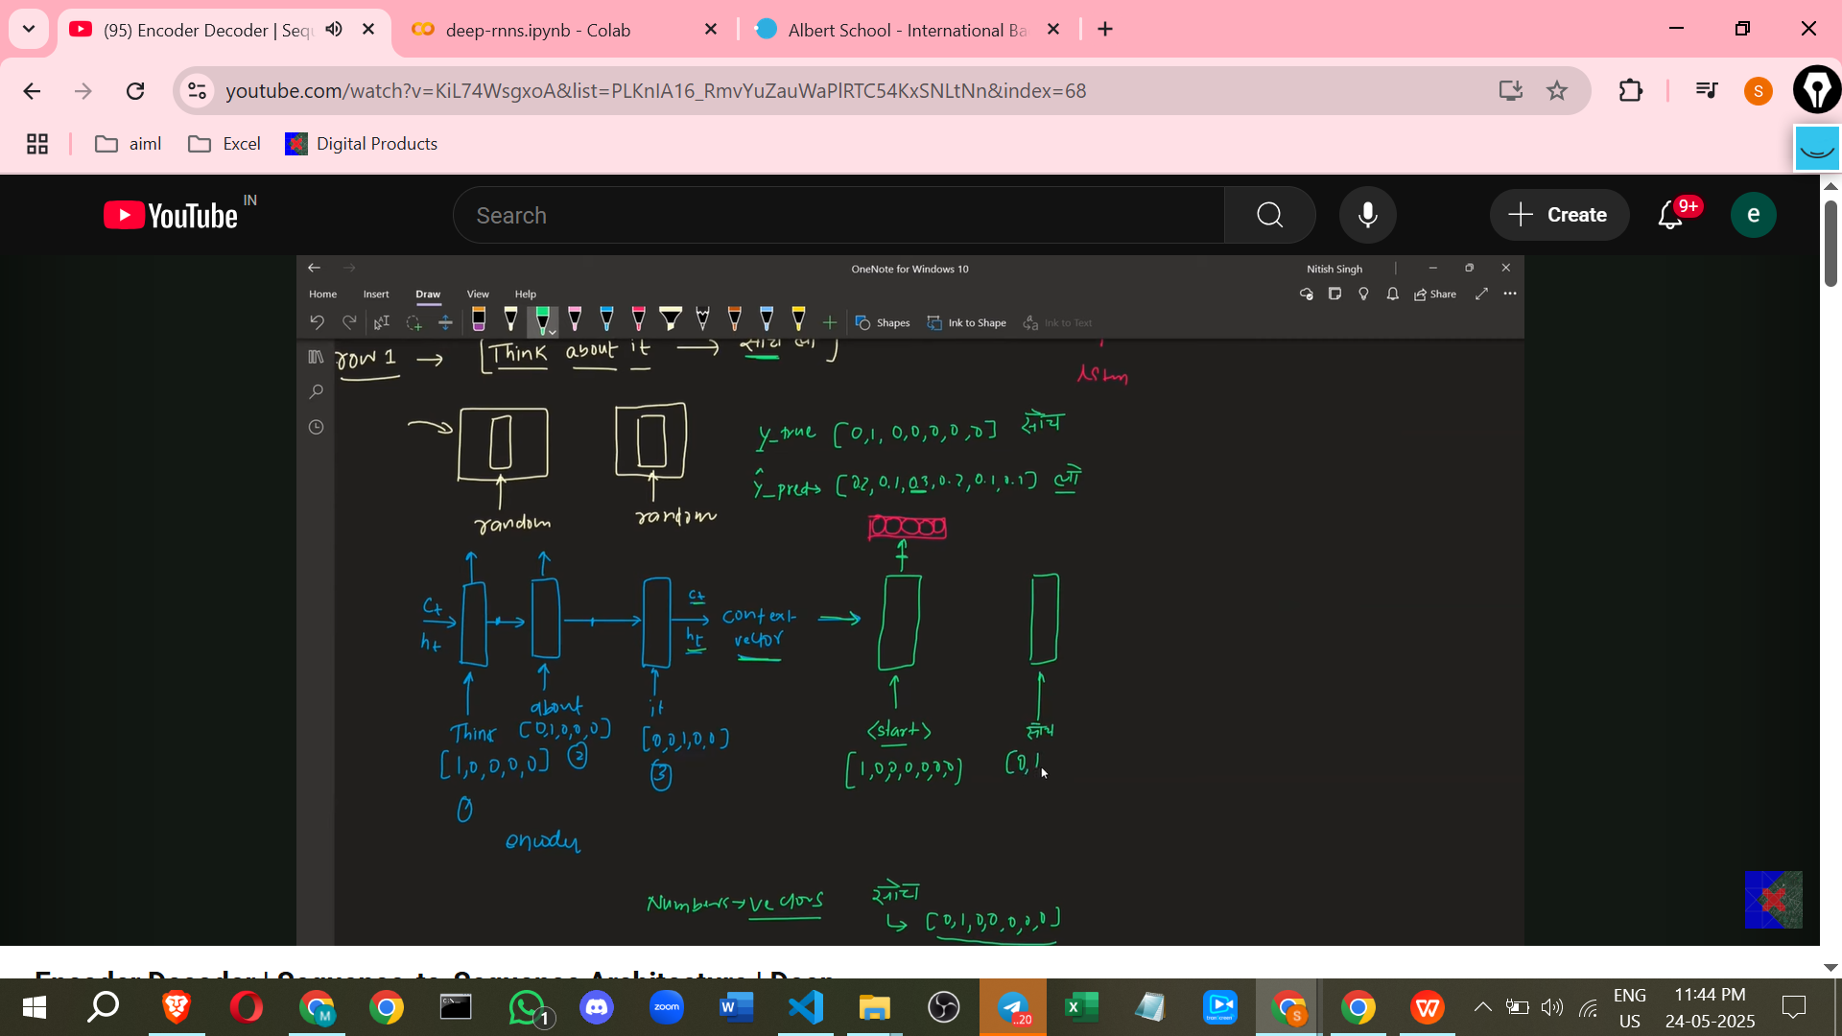

**Forward Pass:**

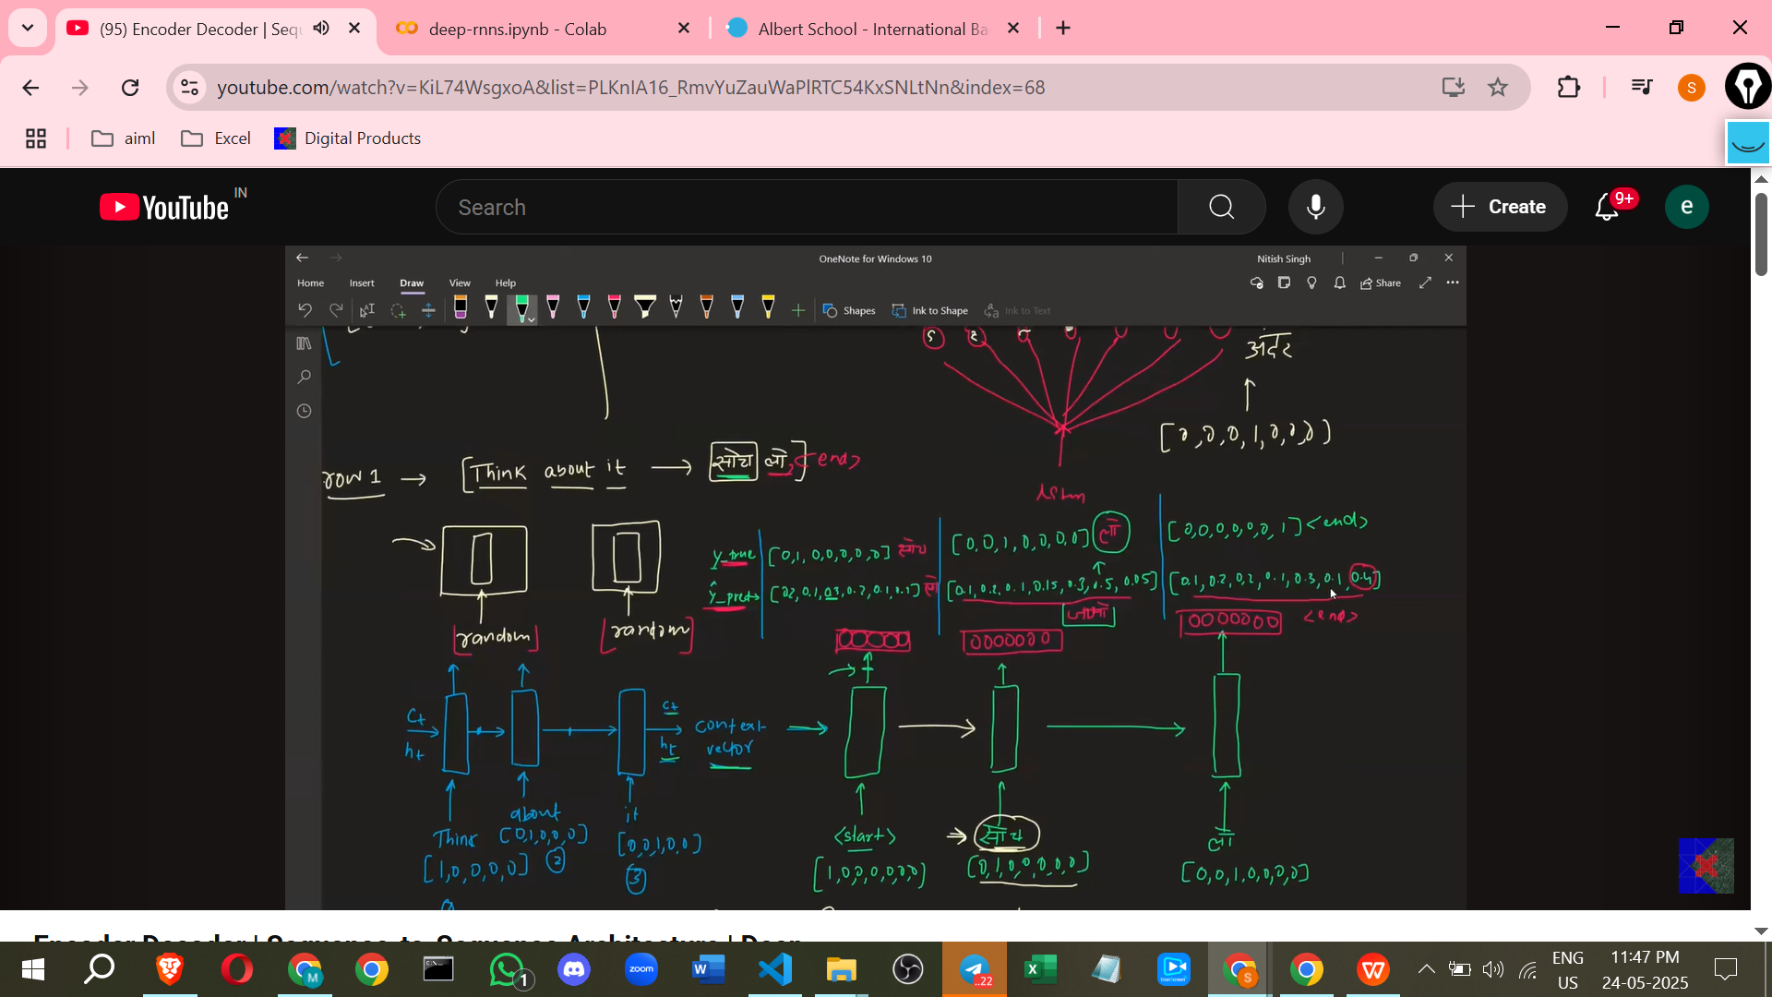

* + An input sentence (as a sequence of one-hot vectors) is fed into the Encoder token by token.
  + The Encoder processes this, updating its internal state.
  + The Encoder outputs its final hidden states as the Context Vector.
  + The Decoder receives the Context Vector and the **Start** token (one-hot encoded) as its initial input.
  + The Decoder produces an output for the first time step by passing its internal state and inputs through a Softmax layer to get probabilities.
  + **Teacher Forcing** is a key technique used *during training*. Instead of feeding the Decoder's *own predicted output* from the previous step as input to the current step, the **correct word from the training dataset** is fed as input. This helps train the Decoder by providing the correct historical context at each step, leading to faster convergence. (Note: This is different from the prediction process).
  + This process continues for all time steps required to generate the target output sequence, up to the End symbol.

**Loss Calculation:**

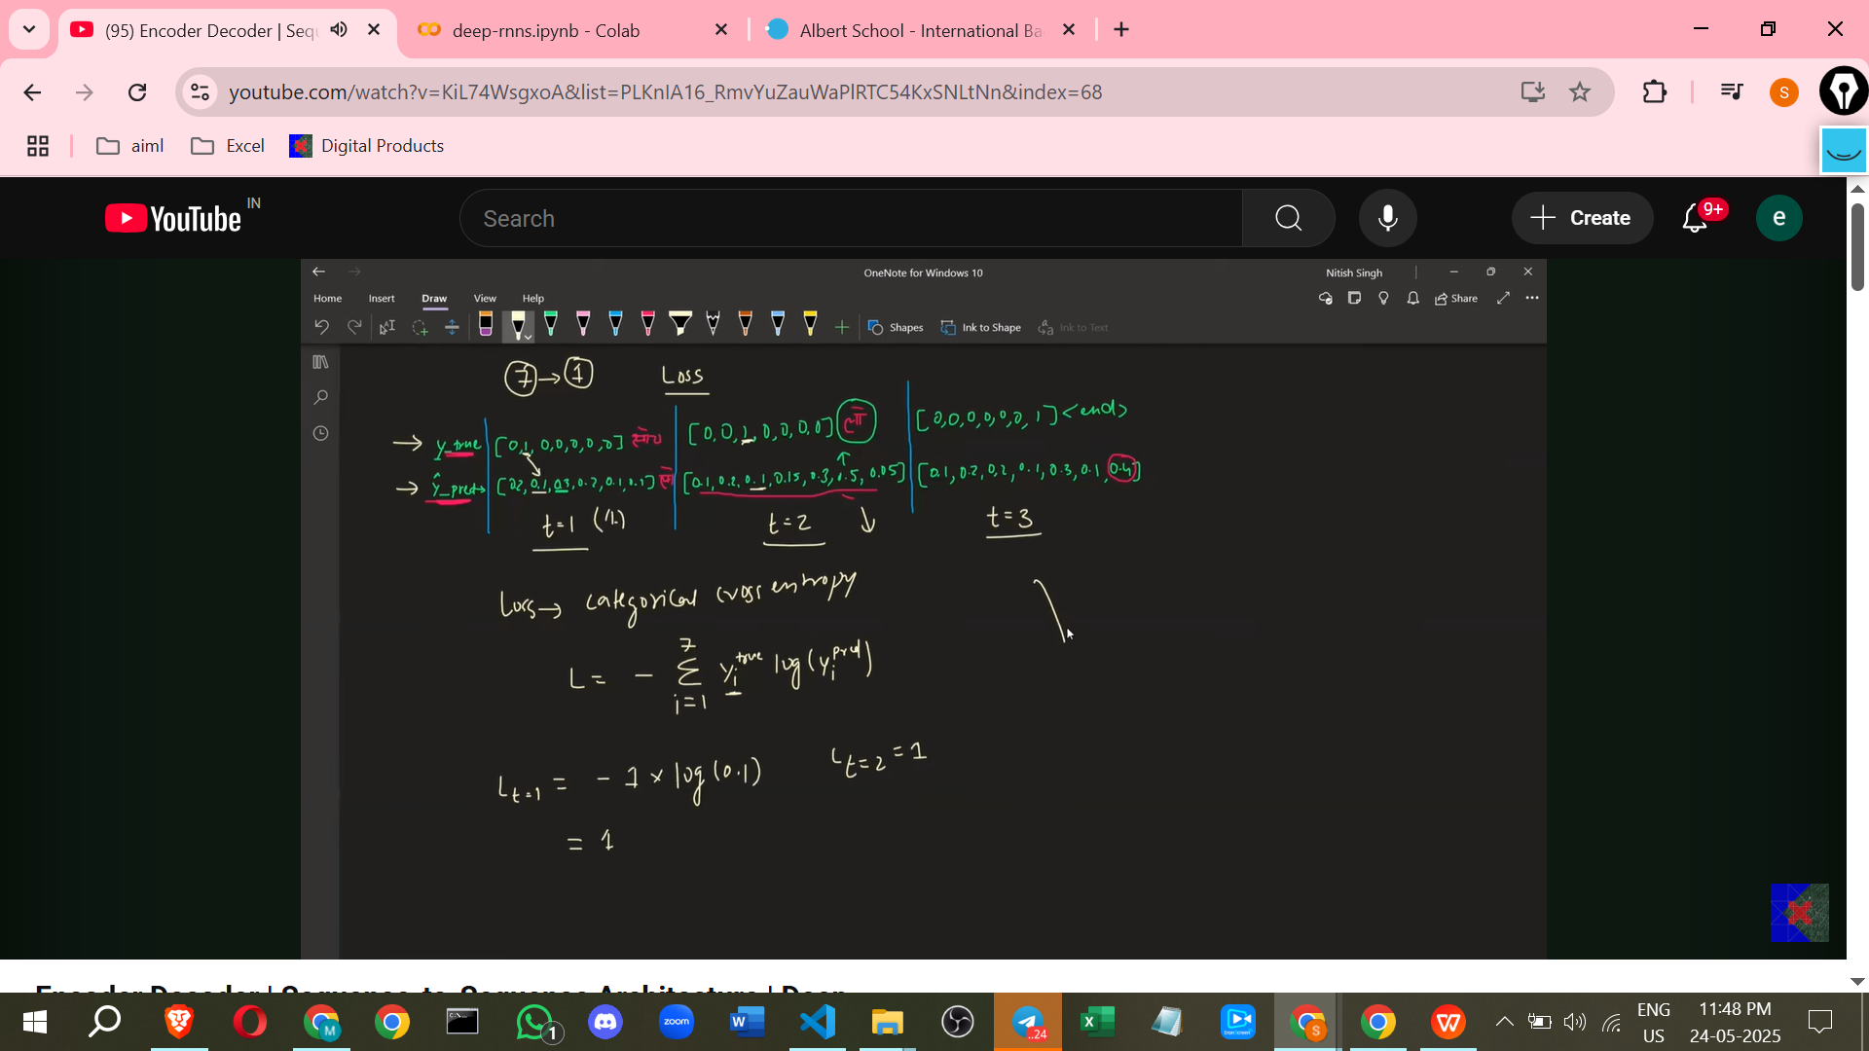

* + At each time step, the Decoder's output probabilities are compared to the **correct output word** from the dataset (represented as a one-hot vector, known as the 'true output' or 'y_true').
  + This is framed as a **multi-class classification problem**, where the model is classifying which word from the vocabulary is the correct output at that step.
  + The **Categorical Cross-Entropy Loss** function is used to measure the error between the predicted probabilities and the true output for each time step.
  + The total loss for a given training example is calculated (e.g., by summing or averaging the losses from each time step). A lower loss indicates better prediction.

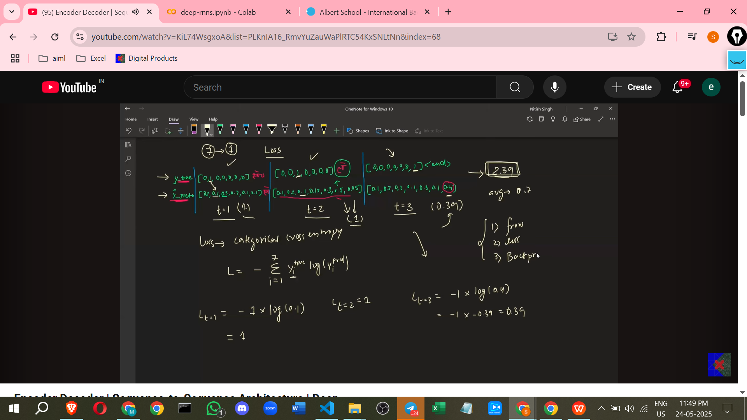

**Backpropagation and Parameter Update:**

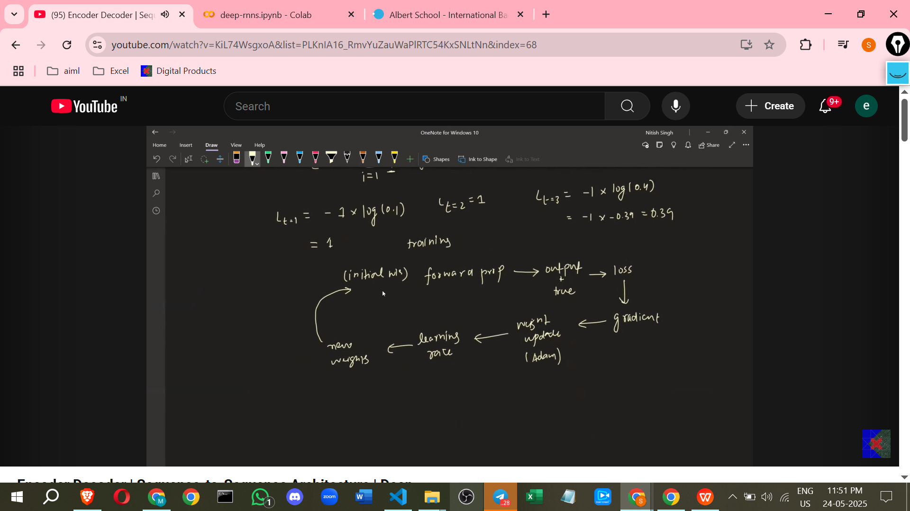

* + After calculating the total loss, **Backpropagation** is performed.
  + This involves calculating the **gradients** of the loss with respect to all the **trainable parameters** (weights and biases) in the Encoder, Decoder, Dense layers, and Softmax layer. Gradients indicate how much each parameter contributes to the loss and the direction in which to change the parameter to decrease the loss.
  + An **Optimizer** (such as SGD, Adam, or RMSProp) is used to **update the parameters** based on the calculated gradients.
  + The **Learning Rate** (a hyperparameter) controls the size of the parameter adjustments made by the optimizer.

The entire process (forward pass, loss calculation, backpropagation, parameter update) is repeated for many training examples and multiple iterations over the dataset, allowing the model's parameters to learn to perform the translation task.

**Prediction Process (Inference)**

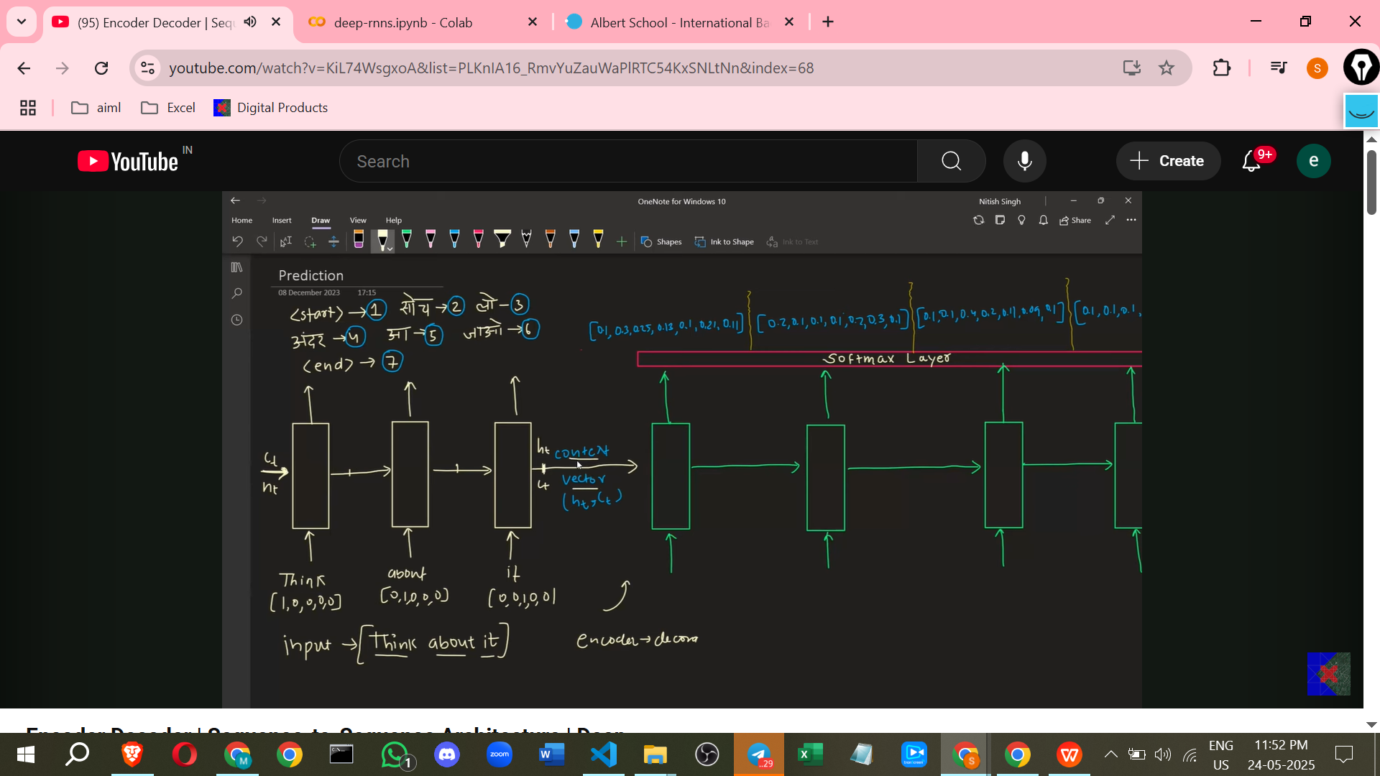

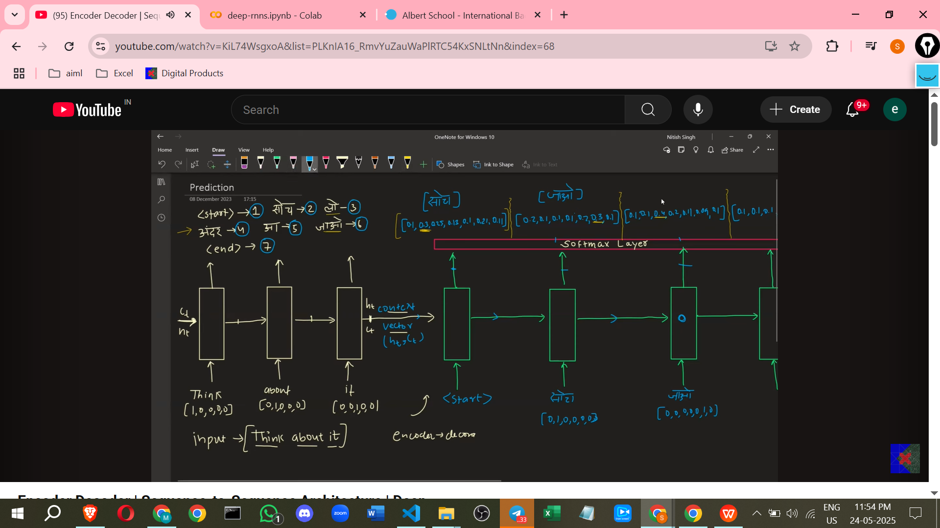

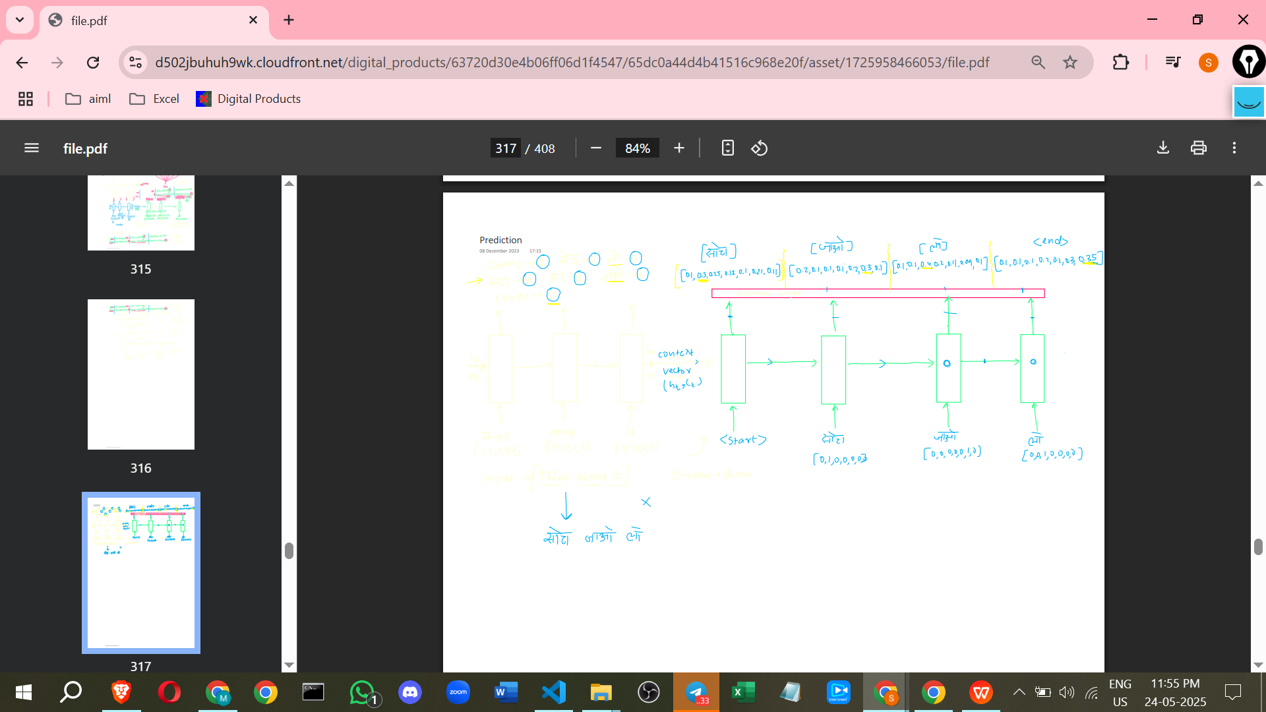

* Once the model is fully trained and its weights are finalised ('frozen'), it is used for making predictions on new, unseen input sentences.
* The new input sentence is tokenized and fed into the **trained Encoder** word by word (e.g., using their one-hot vectors or embeddings).
* The Encoder processes the input and generates the final **Context Vector**.
* The Decoder receives the Context Vector and is started with the **Start** symbol.
* The Decoder produces an output word for the first step by passing its output through the Softmax layer and selecting the word with the highest probability.
* Crucially, **during prediction, Teacher Forcing is NOT used** because the correct output words are unknown. Instead, the **Decoder's *own predicted output* from the previous time step** is fed as input to the current time step.
* This process continues iteratively, with the Decoder's previous prediction feeding the next step, until the Decoder outputs the **End** symbol or a predefined maximum output length is reached.
* The sequence of words outputted by the Decoder is the model's predicted translation. This prediction may or may not be correct depending on the model's training and the complexity of the input.

**Improvements to the Basic Architecture**

Several improvements can be made to enhance the performance of the basic Encoder-Decoder model:

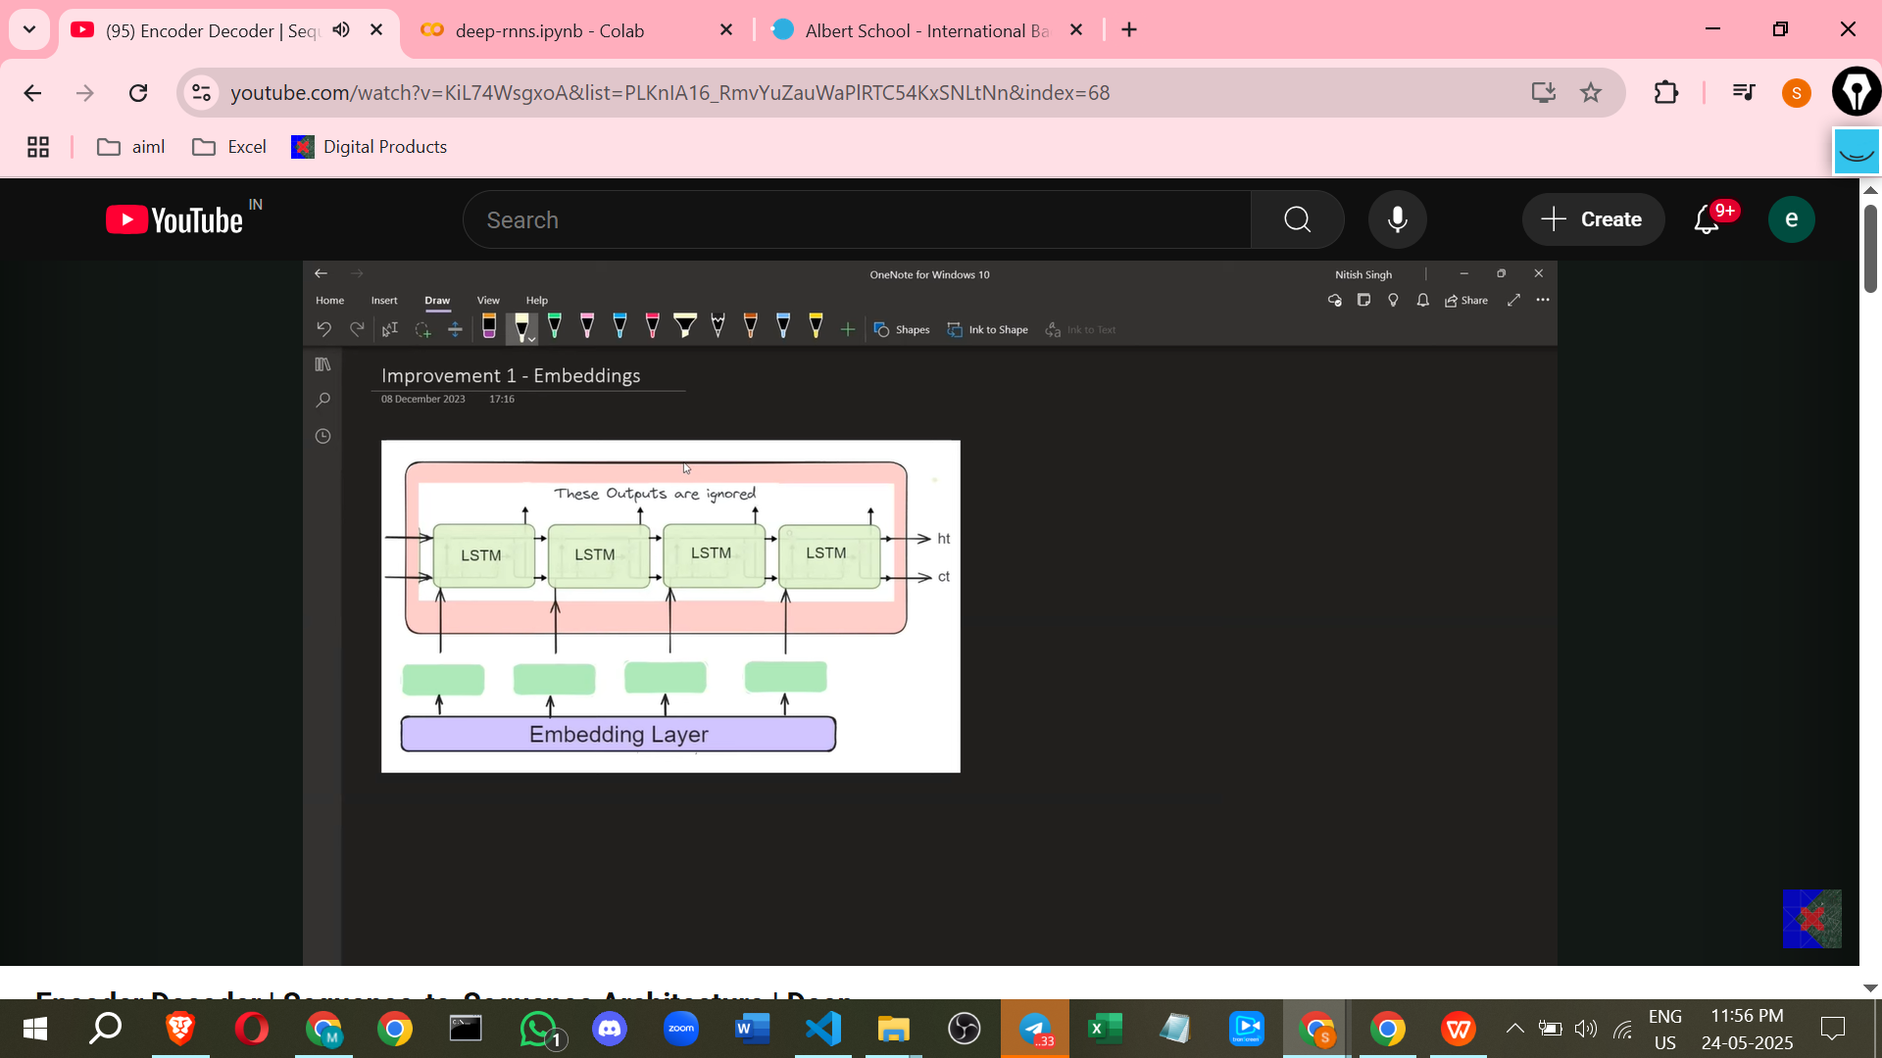

1. **Using Word Embeddings:  
   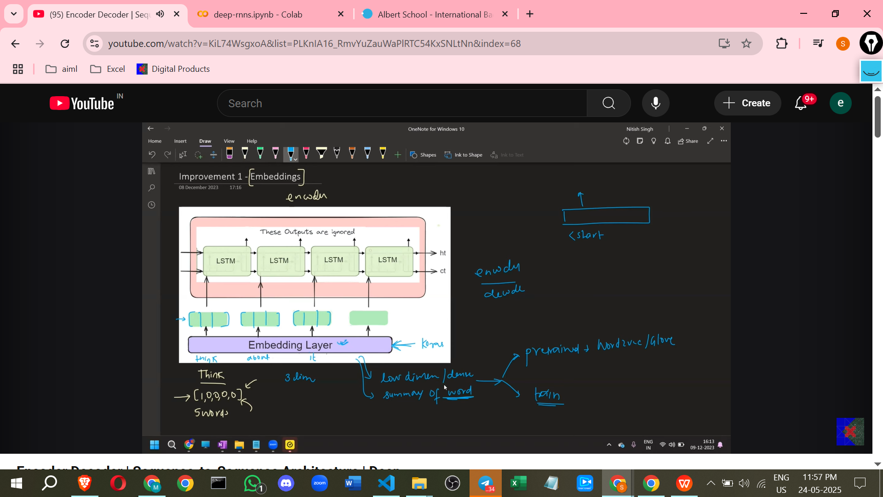**
   * **Problem:** Using One-Hot Encoding for words becomes computationally expensive and inefficient for large vocabularies, as the input vectors become very high-dimensional (e.g., 160,000 dimensions for 160,000 words). One-Hot Encoding also doesn't capture semantic relationships between words.
   * **Solution:** Replace One-Hot Encoding with **Word Embeddings**. Embeddings provide **low-dimensional, dense representations** of words (e.g., 1000 dimensions used in the paper).
   * **Benefit:** Embeddings capture the **meaning and context** of words better than one-hot vectors. They are more efficient to work with. An Embedding layer is added before both the Encoder and Decoder inputs.
   * Embeddings can be **pre-trained** (using models like Word2Vec or GloVe) or an **Embedding Layer can be trained** as part of the overall network, allowing it to learn data-specific relationships.

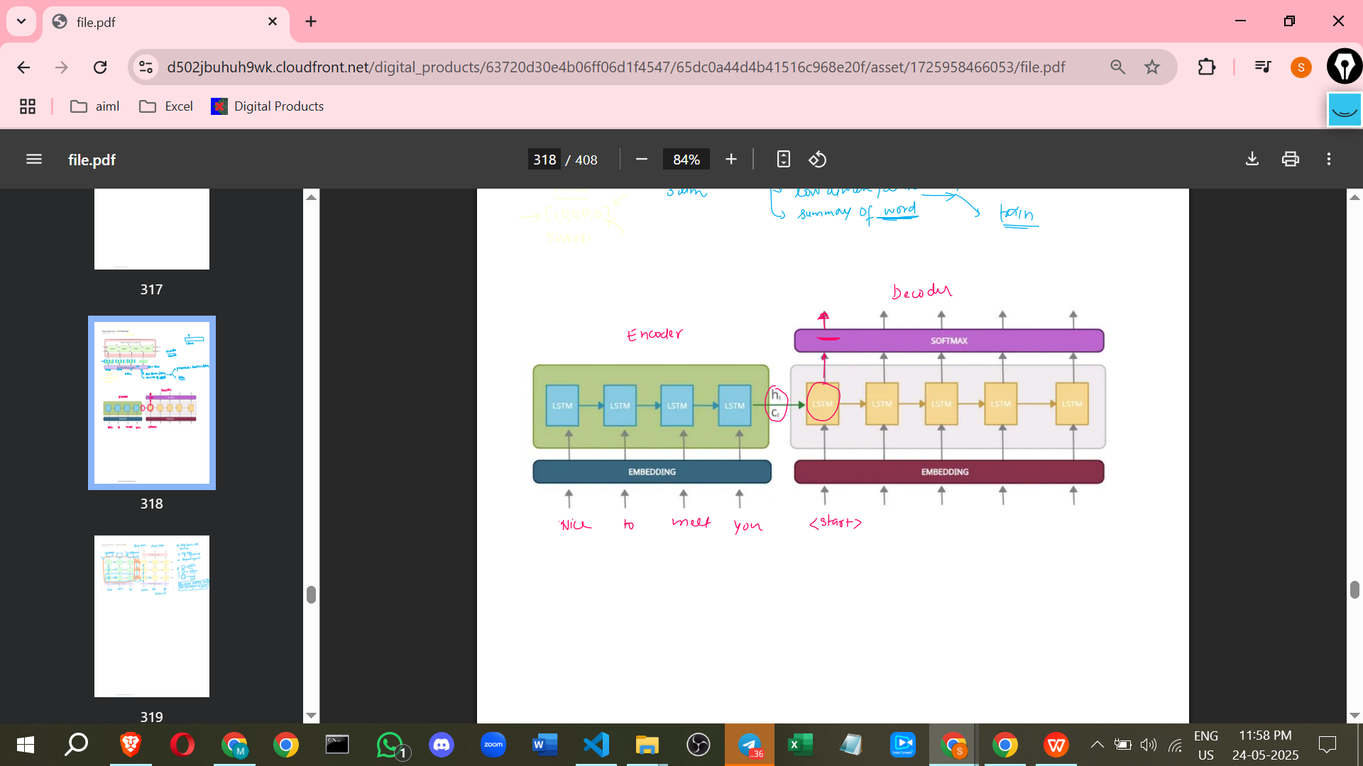

1. **Using Deep LSTMs (Multi-Layered LSTMs):  
   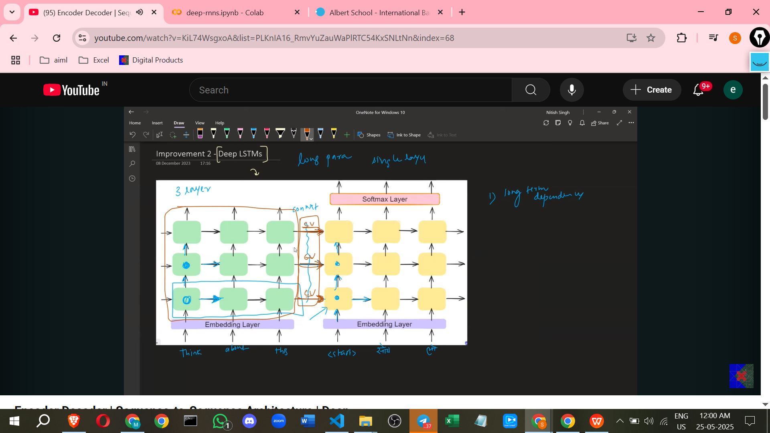**
   * **Solution:** Instead of using a single LSTM layer in the Encoder and Decoder, use **multiple LSTM layers stacked on top of each other**.
   * **Benefit 1: Better Handling of Long-Term Dependencies:** Deep LSTMs are better at processing and summarising **long sequences** like paragraphs. A single Context Vector from a single layer may struggle to capture the full summary of a very long input. Multiple layers provide more capacity to store the sentence summary.
   * **Benefit 2: Capturing Hierarchical Representations:** Deep LSTMs can learn **hierarchical structures** in data. Lower layers might capture word-level features (like singular/plural, verbs), middle layers might understand sentence-level meaning and context, and higher layers might grasp paragraph-level context.

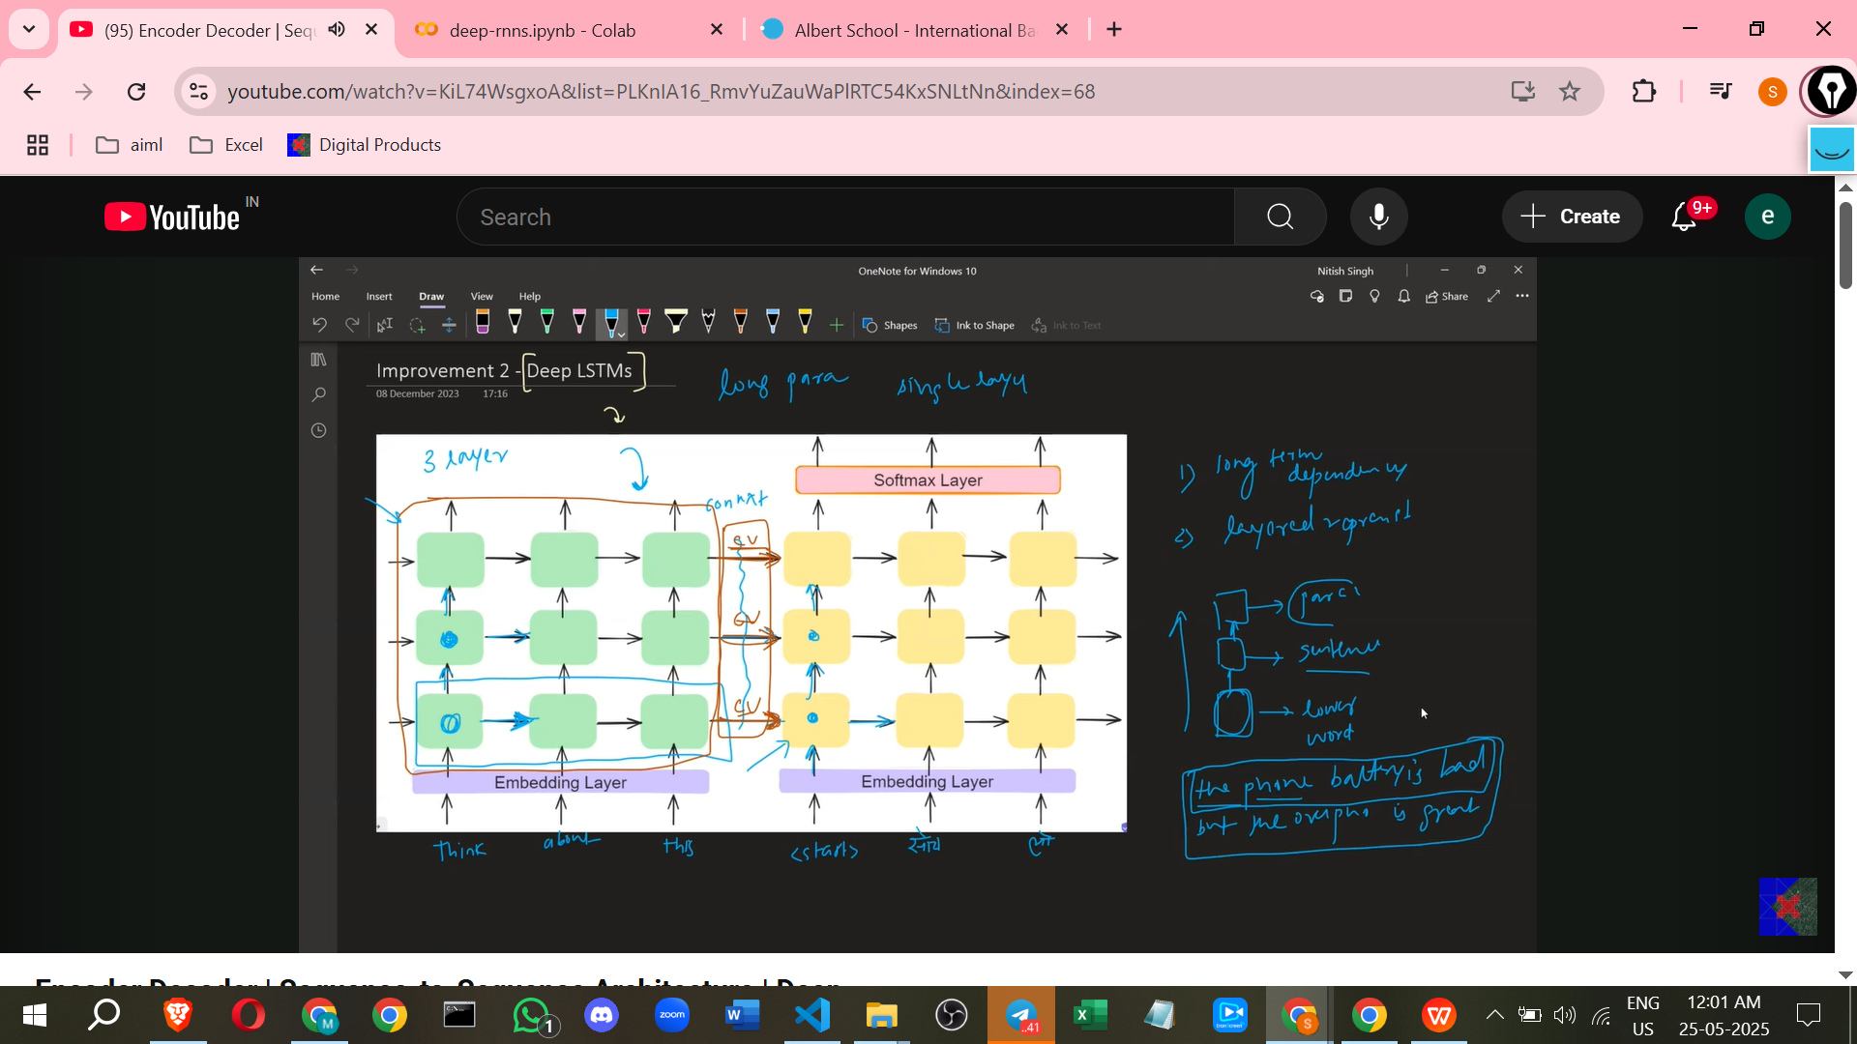

* + **Benefit 3: Increased Model Capacity:** Adding more layers increases the number of parameters, giving the model more capacity to learn complex patterns and subtle variations in the data. This can lead to **better generalisation** (less overfitting) and improved performance on new, varied inputs, provided sufficient training data.
  + The original paper empirically showed that **deep LSTMs give better results** than single-layered LSTMs. They used a **4-layer deep LSTM** with 1000 units in each layer.

1. **Reversing Input Sequence (for Encoder):**
   * **Solution:** Feed the input sequence to the Encoder in **reverse order**. For example, "Think About It" becomes the input "It About Think". The Decoder still produces the output in the correct order ("सोच लो").
   * **Rationale:** This trick reduces the distance in processing steps between the first word of the input and the first word of the output. For "Think About It" -> "सोच लो", reversing makes "Think" closer to "सोच लो" (by being the last input word) compared to being the first. This can help with gradient flow and make it easier for the model to associate the start of the output sequence with the start of the input sequence.
   * **Caveat:** This technique does not work for all language pairs. It seems more effective for languages where initial words contribute significantly to the context, such as English. The original paper applied this successfully for English-to-French translation, showing improved quality.

**Details from the Original Paper**

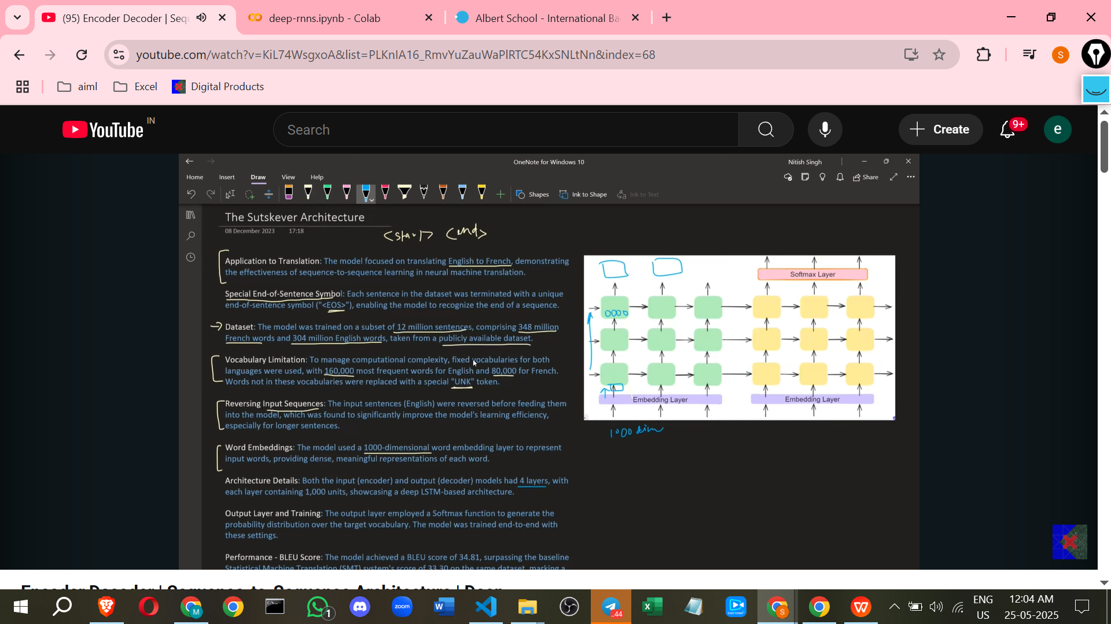

The original paper that proposed the Encoder-Decoder module was by Ilya Sutskever et al.. Key details mentioned from the paper include:

* **Task:** Machine Translation, specifically English to French.
* **Symbols:** Used a special **End of Sentence (EOS)** symbol, which is stated to be used *instead of* the Start and End symbols described in the general architecture explanation.
* **Dataset:** Trained on a large public dataset containing around **12 million sentences**, with millions of words in both French and English.
* **Vocabulary Size:** English input vocabulary was about **160,000 words**, and French output vocabulary was around **80,000 words**. An **UNK (Unknown)** token was used for words not in the vocabulary.
* **Word Embeddings:** Used **1000-dimensional** word embeddings.
* **Architecture:** Utilised a **4-layer deep LSTM** with **1000 units** in each layer for both the Encoder and Decoder.
* **Output Layer:** Used the **Softmax function** for generating output probabilities.
* **Performance:** Achieved a **BLEU score** of 34.8, which **surpassed the performance of baseline statistical models** at the time, contributing to the paper's impact. BLEU score is a standard metric for evaluating the quality of machine translation.

This architecture provides a solid foundation for tackling sequence-to-sequence problems, laying the groundwork for subsequent advancements in the field.